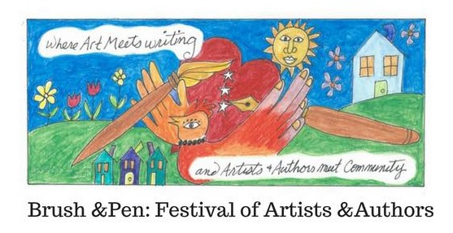

VENDOR REGISTRATION FORM
EVENT DETAILS:
Date: August 18th, 2018
Location: Blue Harbor Center for the Arts
559 Humboldt Ave, St. Paul, MN 55107

Time: 10 AM- 7PM
Festival 10-5
Meet and Greet Artists and Authors 5-7
Guest admission (12+) $5
Vendor Pricing $100 for booth. Participants provide their own six-foot table, covering and display. Registration deadline is July 21st, 2018
EARLY BIRD SPECIAL: $75 if you register before June 30, 2018
To Register complete the form and payment information on page 2.

VENDOR INFORMATION
Business Name: ____________________________________________________
Contact Name:______________________________________________________
Address: __________________________________________________________
City/State/Zip_______________________________________________________
Phone :___________________________________
Email Address: _____________________________________________________
Website: __________________________________________________________
Are you and ARTIST___ Medium ______________________________________
or AUTHOR___ Genre_______________________________________
What will you be selling? ______________________________________________
__________________________________________________________________
Do you need electricity? ______________________________________________
Payment Method Circle one: Credit/Debit PayPal* Square Invoice
CARD INFORMATION:
Name on card ______________________________________________________
Card Number: ______________________________________________________
Expiration ___________________ CVC _________
By signing this completed form along with payment submission, you agree to the terms and conditions of the Festival. ***** Your space will be secured after payment is received and processed. There is limited space so please get your registration in as soon as possible to guarantee your space.
Contact infor: Katelyn Mariah 651-955-3673 Email Mystickcreekpublishing@gmail.com*
TERMS AND CONDITIONS
- Payment and registration is due no later than July 21st, 2018
- A signed MN Dept of Revenue Operation Certificate of Compliance ST19 is required. Bring it with you to the show. You can print on at MN Dept of Rev
- I agree to comply with all local and state regulations
- One vendor is allowed per table
- I understand that the table assignments will be made at the sole discretion of Katelyn Mariah
- Tables must be manned by vendor/helper at all times
- Vendors will adhere to established check-in, set-up and tear down times. Details will be sent to participants 1 week prior to the event if not sooner
- All supplies and excess stock must be stored under the tables and out of sight.
- I grant Katelyn Mariah permission to use any photography, audio or video taken at the event for general use in advertising future events.
- I will not hold Katelyn Mariah , her agents or employees responsible to any loss or damage to vendors wares, exhibits or personal property.
- I will not hold Katelyn Mariah or anyone connected with the show responsible for any injuries caused by products sold or displayed by vendors.
- I release Blue Harbor Center for the Arts from any damage, injury or loss to any person or goods which may arise from the rental and occupation of this space or the participation in the event by me, the vendor.
- I agree to hold Katelyn Mariah and Blue Harbor harmless of any loss, injury or damage.

